**Exercise 1.**

DC Measurement and Analysis Report.

Table of Contents

List of Figures 1

Abstract 3

Part 1: Analysis of the Resistive Voltage Divider 4

Part 2: Analysis of the voltage divider circuit with load 7

Part 3: Examine of the influence of temperature on the output voltage 9

Part 4: Determination of the characteristics of a semiconductor diode 11

Part 5: Study of a bipolar transistor 13

Part 6: Homework 18

Task 1: 18

Task 2: 18

Task 3: 20

# List of Figures

Figure 1 Tested Divider Circuit. 4

Figure 2 Vout=f(VV1) Plot Characteristic. 4

Figure 3 DC Sweep syntax and RR parameter VDC. 5

Figure 4 Vout=f(VV1) Plot Characteristic. 5

Figure 5 Step parameter. 5

Figure 6 Vout=f(VV1) Plot Characteristic. 6

Figure 7 VDC with additional resistive load R3. 7

Figure 8 Vout=f(VV1) Plot Characteristic. 7

Figure 9 VDC with New Param Directive. 8

Figure 10 Vout=f(VV1) Plot Characteristic. 8

Figure 11 Temperature Influence Study. 9

Figure 12 Vout=f(T) Plot Characteristic. 10

Figure 13.1 Vout=f(T) Plot Characteristic. 10

Figure 14 Circuit for Measuring the Characteristics of Zener Diode. 11

Figure 15 Zener Diode Characteristic. 12

Figure 16 Circuit for Determination of the Input Characteristic. 13

Figure 17 IB=f(UBE) Plot Characteristic. 13

Figure 18 Circuit for Determination of Input Characteristic. 14

Figure 19 IB=f(UBE) Plot Characteristic. 14

Figure 20 IB=f(UBE) Plot Cursor. 15

Figure 21 Circuit for the Output Characteristics Determination for IB Values. 15

Figure 22 IC=f(UCE) Plot Characteristic 16

Figure 23 Zoomed in IC=f(UCE) Plot Characteristic. 16

Figure 24 Circuit from Figure 20 with .step SPICE Directive 16

Figure 25 BF parameter change IC=f(UCE) Plot Characteristic. 17

Figure 26 Circuit for Rectifying Diode. 18

Figure 27 Forward Bias 18

Figure 28 Reverse Bias 18

Figure 29 Schottkey Diode Circuit 19

Figure 30 Reverse Characeristic. 19

Figure 31 Forward Characteristic. 19

Figure 32 Determination of the Static Operating Point of the Transistor. R1=372k R2=1k. 20

Figure 33 IC 20

Figure 34 Calculations 21

# Abstract

The aims of this laboratory exercise were to introduce an DC voltage source from the theory to practice. The aims of this report are to learn about possibilities of DC analysis, simulation of the resistive voltage divider, simulation of the characteristics of a semiconductor diode and static characteristics of a bipolar transistor.

# Part 1: Analysis of the Resistive Voltage Divider

To start I have firstly created a diagram of the voltage divider circuit.

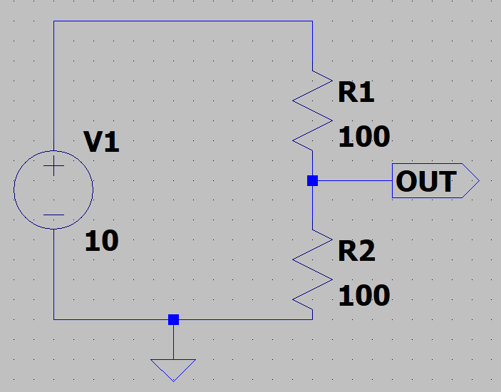

Figure 1 Tested Divider Circuit.

Please see the following labels: Voltage Source labelled as V1, resistors labelled as R1 and R2, Label OUT is output and the triangle at the very bottom of the figure is the ground. These few components in this digital simulator enable us to create a voltage divider circuit.

Values of each component have been entered manually, as per instruction, by clicking with the RMB over each component. Seek: R1 & R2 set to 100Ω, voltage source V1 set to 10V. To continue further we must produce a characteristic plot of the Vout function of V1 – so Vout=f(VV1).

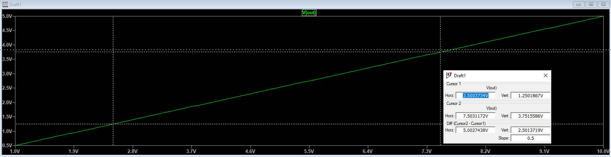

Figure 2 Vout=f(VV1) Plot Characteristic.

In Figure 2 please seek the analysis of the characteristic plot, in between V1=2,5V and V1=7,5V. See the cursors presenting the horizontal difference of 5V and vertical difference of 2,5V.

Deeper down the rabbit hole we go, where not we skip ahead through the basic parts of the laboratory. We now set the value of R2 to “{rr}” parameter. Another parameter is the “.param RR=100”, this is to se the R2 value. Following, which we add a simulation command to computer the DC operating point of our circuit, from which we step independent source. In this option it’s worth to note that the DC sweep command treats capacitances as open circuits and inductances as short circuits, which is the correct way to go. We enter the following command syntax “.dc V1 1 10 0.1”, these are out DC analysis parameters.

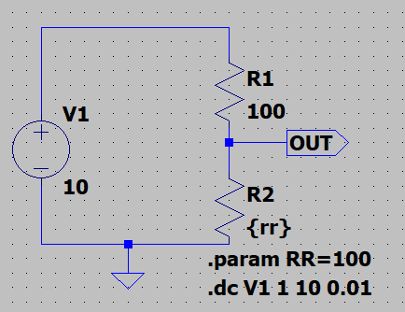

Figure 3 DC Sweep syntax and RR parameter VDC.

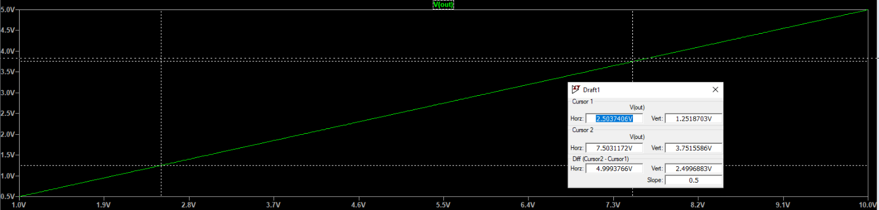

Figure 4 Vout=f(VV1) Plot Characteristic.

Here we see, that in Figure 4 we see no difference between Figure – plot wise no difference. However, only remarkable difference can be noticed in the structure of how the circuit is used (using syntax commands).

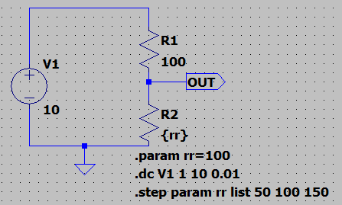

Figure 5 Step parameter.

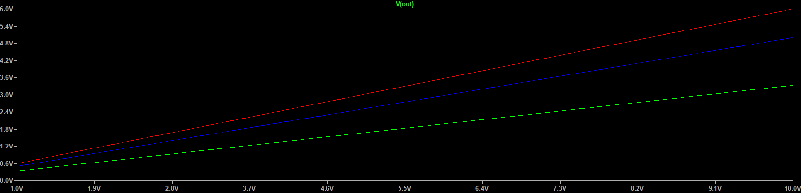

Figure 6 Vout=f(VV1) Plot Characteristic.

As we can see between Figure 6 and Figure 4 we have a general difference between the plots, since now we have different parameters each step in the circuit. So what the .step param does is that it manipulates the RR directive in R2 and simply steps the resistance up, firstly from 50Ω to 150Ω.

The procedure is to find the output Vout voltage of our analyzed system by finding V1=5V for all possible resistance values in the plot characteristic of R2 resistive element.

Green 50Ω: 0.33333V

Blue 100Ω: 0.5V

Red 150Ω: 0.6V

To conclude, in the first task of our laboratory experiment we have introduced SPICE simulator and a VDC (Voltage Divider Circuit) from, which we’re able to seek the output voltage being changed on the basis of the resistance on resistor R2. From the behavior noticed in between Figure 2 and Figure 4 we see that the higher the output voltage is visible the lower the resistance is on resistor R1.

# Part 2: Analysis of the voltage divider circuit with load

To start the second part of this laboratory I have firstly created a diagram of the voltage divider, however this circuits only difference is the change in load. Please seek Figure 7 that presents the described circuit.

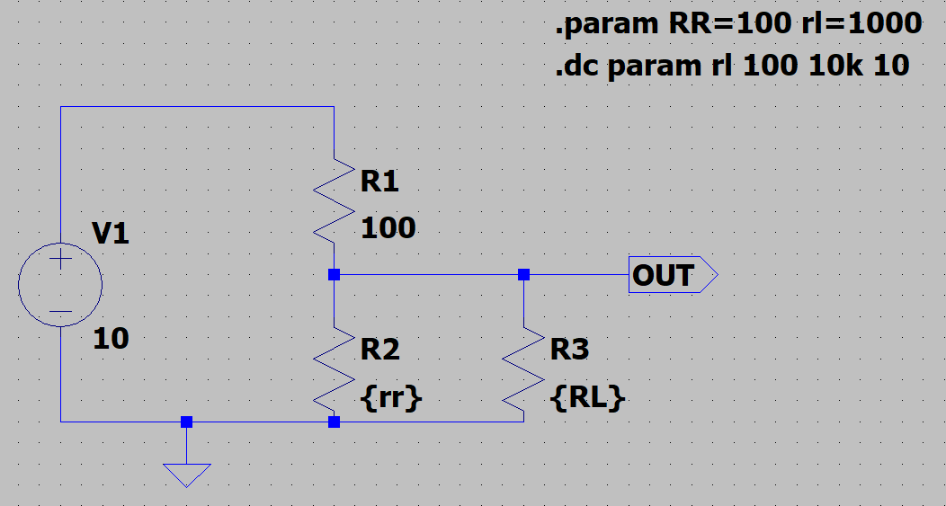

Figure 7 VDC with additional resistive load R3.

Please note that the .param syntax has changed as well as the DC sweep command syntax. Since we have a new R3 load, we now set the different values of R3 between 100Ω, 10kΩ and 10Ω.

The simulation has been run with the new VDC circuit with the additional resistive load from Figure 7 with the new included parameters. From Figure 8 we can see the affect this operation has made on our analyzed system, please see that there is a curve on our characteristic plot from which we see that our resistor is operating successfully. By values in axis i.e. the voltage input and the rated resistance, we’re able to see that at the step increment of 10Ω we see our start value of 100Ω, the greater the voltage input from V1 we see that the resistance keeps steady and voltage does not rise. At 10Ω we have 833mV whilst at 10k we have almost 4.97V (est. 5V).

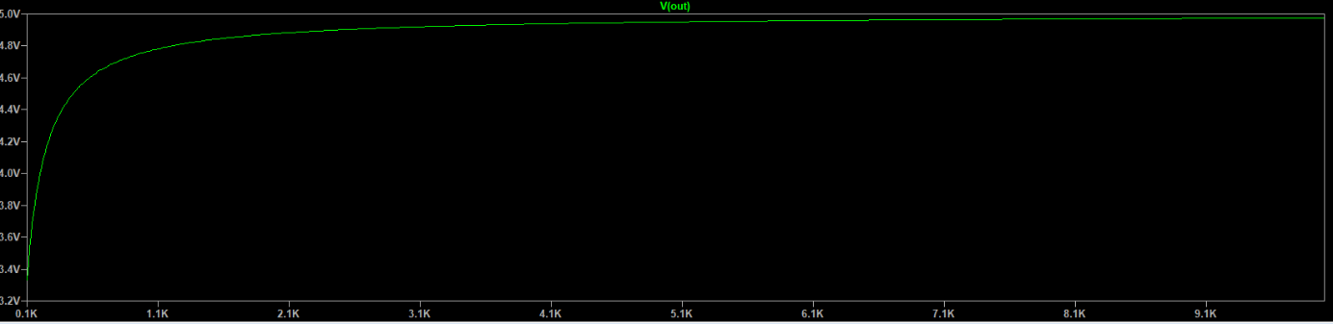

Figure 8 Vout=f(VV1) Plot Characteristic.

Moving on forward we now must add the .step parameter into the SPICE directives. Please see Figure 9 presenting the new circuit with the added syntax command as well as Figure 10 presenting the plot characteristic of Vout.

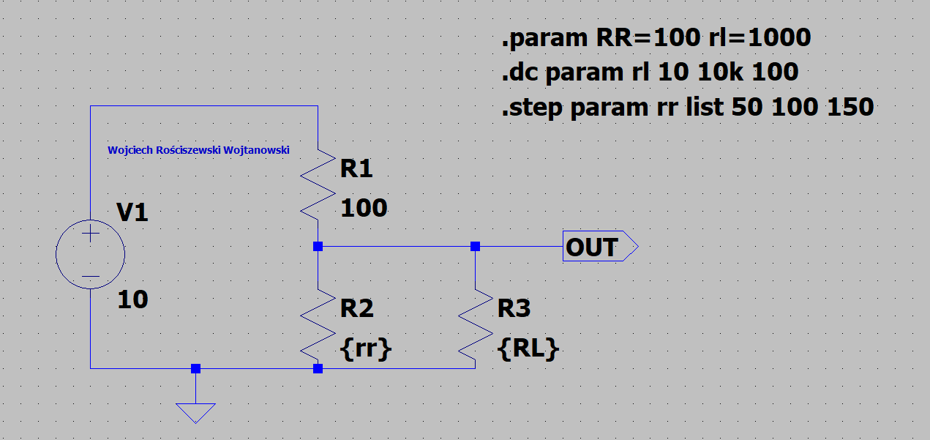

Figure 9 VDC with New Param Directive.

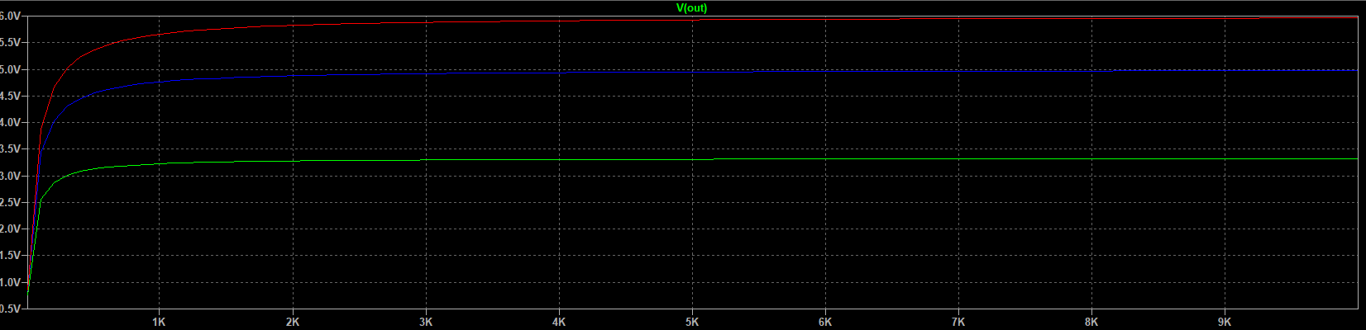

Figure 10 Vout=f(VV1) Plot Characteristic.

The .step command syntax directive causes the simulation/analyzed circuit to be simulated repeatedly whilst stepping through our provided model parameters of an element. We see that the .step command directive makes three different coloured traces in our characteristic plot window, whereas the .dc completes a similar task however plots everything into one simulation window. From which we would be able to view each change separately by using the .step command directive in SPICE simulator. Another thing worth to mention is that the .dc directive enables the circuit to run, as it is a specification of how the simulation should progress/operate whilst the .step command only influences the element values such as in this case resistance, whilst DC specifies the stop time, increment of Voltage source etc.

# Part 3: Examine of the influence of temperature on the output voltage

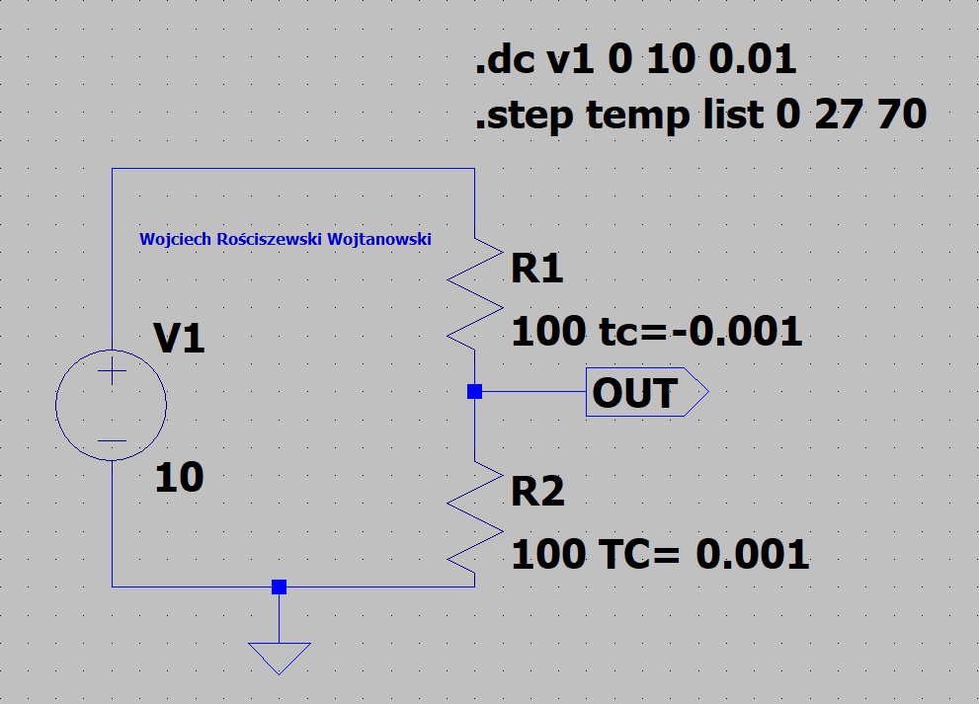

Figure 11 Temperature Influence Study.

Continuing forward into the next task, I have proceeded to as the TC (temperature coefficients) for each resistor. The TC is a factor that can determine that affects the resistive elements producing a resistance value according to the equation:

|  |  |  |
| --- | --- | --- |
|  | $$R=R_{NOM}∙(1+TC∙\left(Temperature-T_{NOM}\right))$$ | (1) |

Where:

TNOM - Nominal temperature of a circuit is 27°C.

RNOM – Resistor Nominal Temperature

It’s worth to note that whenever you buy a resistor from the manufacturer, we must look inside the company data sheet, from which we can seek information such as Linear Temperature Coefficient meaning that this information is already provided by the manufacturer.

Below please see the figure presenting out plot characteristic with temperature aiding as one of the influencing plot characteristic factor.

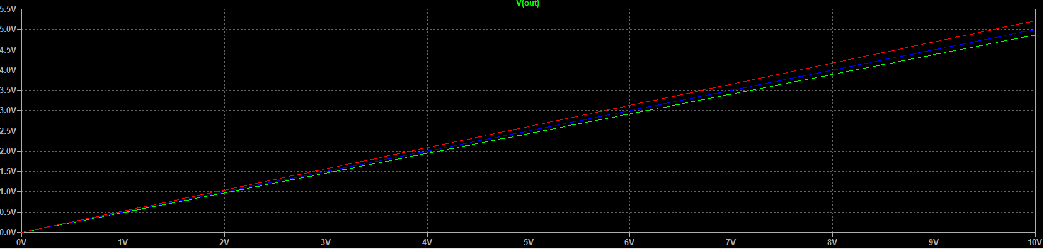

Figure 12 Vout=f(T) Plot Characteristic.

With the voltage of 10V, and the temperature of 25°C We receive the UOUT voltage of 4.98V. In the below please see my other example that presents the UOUT at -99°C. And here we have a big voltage difference, exactly we have UOUT of 4.36V so difference of 0.62V. In figure below see that blue line is 25°C And green line is -99°C.

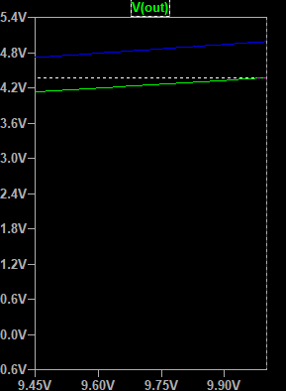

Figure 13.1 Vout=f(T) Plot Characteristic.

To conclude, in the third task of our laboratory experiment we have introduced temperature parameters to a VDC (Voltage Divider Circuit) from, which we’re able to seek the output voltage being changed on the basis of the temperature factor. From the behavior noticed in between Figure 12 and Figure 12.1 we see that the lower the output voltage is visible the higher the temperature must be.

# Part 4: Determination of the characteristics of a semiconductor diode

The next part of the laboratory exercise is to determine the Zener diode characteristics, to being I followed the provided instruction set and drawn a circuit scheme to simulate the characteristics. For this purpose, I have used the BZX84C6V2l Zener diode. Please seek Figure 13 where we can see described circuit and elements.

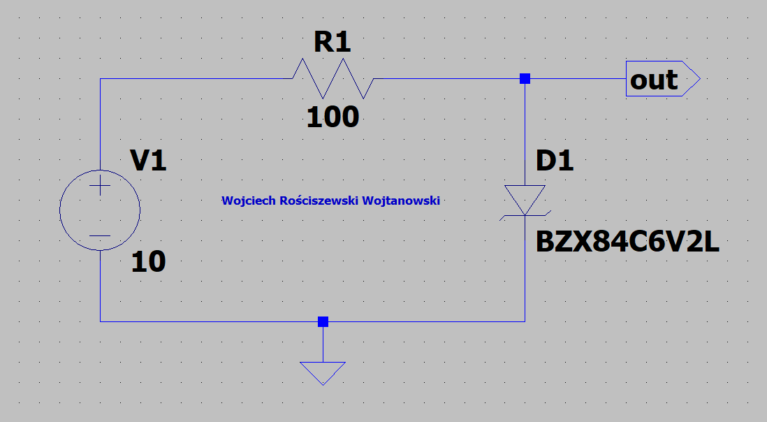

Figure 14 Circuit for Measuring the Characteristics of Zener Diode.

Since I have previous experience with simulation of Zener diodes, I can already assume that in the next part of the exercise the plot of V(out) will be as follows: Prediction is that at the end of normal operating range we will find out breakdown voltage, also known as the Zener knee. Following through we have no flow of current till throughout the Zener breakdown region, after passing 0 mark of voltage v current we will find the forward bias region, at which we will fine the region where the Zener diode is activated and allows current to flow, as I remember from Semiconductor lectures the Zener voltage forward current is between 0.3 – 0.7 since this depends on the voltage. We shall find out what is our forward bias for this specific diode D1.

Below please see the generated plot characteristic. As seen in Figure 14, the figure is not exactly the same as Figure 8 “Zener diode characteristics” provided in the instruction manual “Analiza stałoprądowa DC oraz analizy statystyczne Worst Case i Monte Carlo” provided. However, we can clearly see how the Zener diode operates. That the minimum Zener voltage provided is 5.8 whilst the maximum Zener voltage is 6.6, at these values the Zener diode operates. At particular example the Zener diode breaks down at 6.2V.

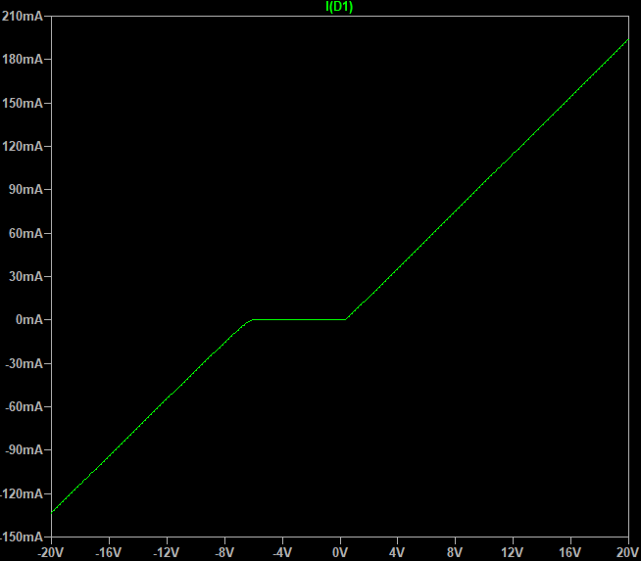

Figure 15 Zener Diode Characteristic.

As seen throughout this exercise we have proved that the Zener diode is quite accurate with its specific breakdown voltage. From the practical use, Zener diodes can be used for an inexpensive method of building a voltage regulator (combined with the correct resistive and control elements over voltage and current supply). Therefore, we can state from this that Zener diodes can be used to just stabilize voltage. So, summing up, the Zener diode operates at specific voltages that are and must be greater than the breakdown voltage (else known as the peak reverse voltage).

# Part 5: Study of a bipolar transistor

For the last part of our laboratory exercise we will test the input characteristics of the bipolar transistor.

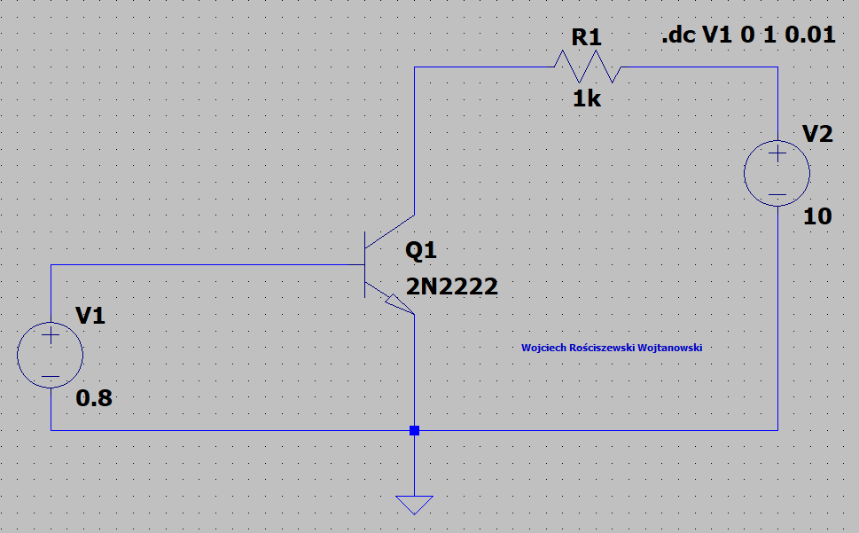

Figure 16 Circuit for Determination of the Input Characteristic.

Below please find the IB=f(UBE) plot characteristic generated from the circuit Figure 15.

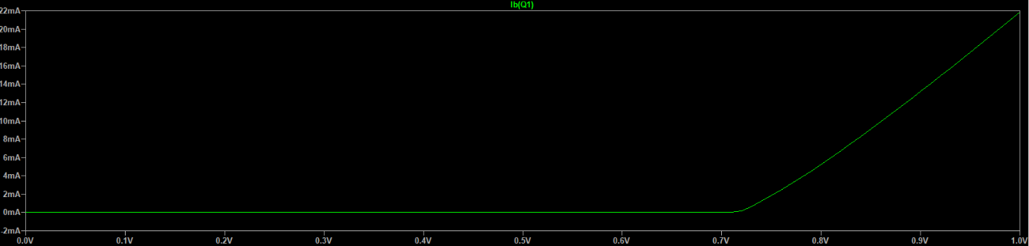

Figure 17 IB=f(UBE) Plot Characteristic.

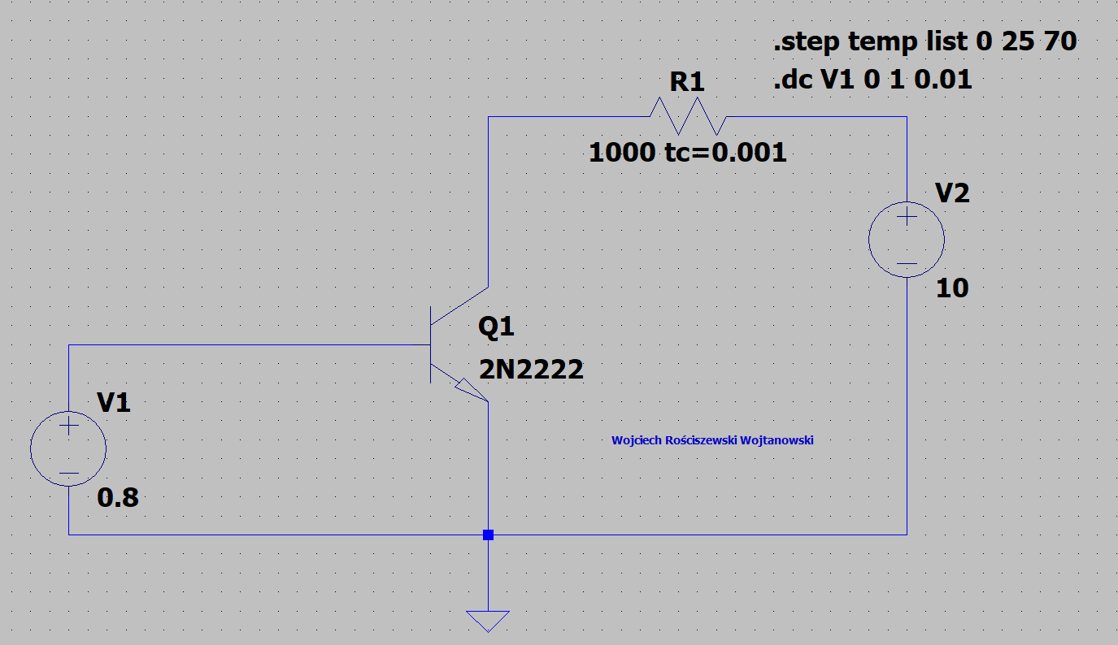

Figure 18 Circuit for Determination of Input Characteristic.

In the above please seek Figure 17, as seen the only difference in this circuit scheme is the additional .step command and the temperature variable added into the resistive element R1.

The simulation has been run, seek figures in the below that present the plot characteristics.

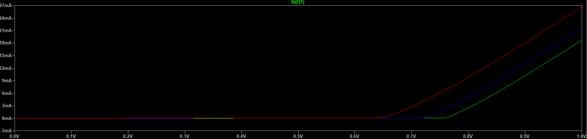

Figure 19 IB=f(UBE) Plot Characteristic.

If we click onto the transistor element with RMB we can select different models, but also see a lot of details. We see that our selected transistor is BF=200 this is our β value else known as current gain value.

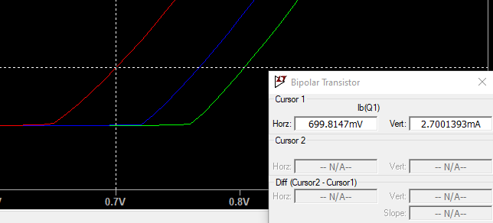

Figure 20 IB=f(UBE) Plot Cursor.

With reference to Figure 19 and Figure 18 in the above. As seen in the graphs we have multiple colours, where the temperature is divided by the step command. Green is the 0°C, blue is the 25°C and red is the 70°C. We see that at 70°C, and before 0.7V our curve starts rising and at point of 0.7V we have the current value of 2.7mA.

For the next part we’ll create the current value .step syntax directive for SPICE, once added this’ll set the current values of current source I1 to 10μA, 20μA and 30μA.

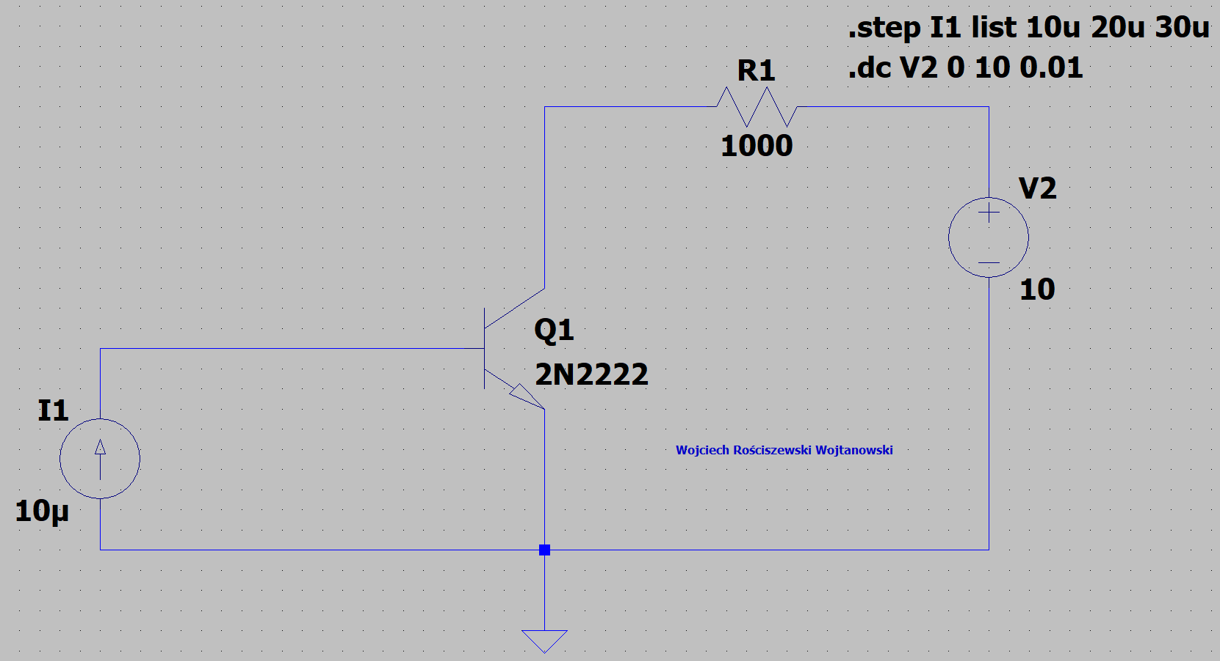

Figure 21 Circuit for the Output Characteristics Determination for IB Values.

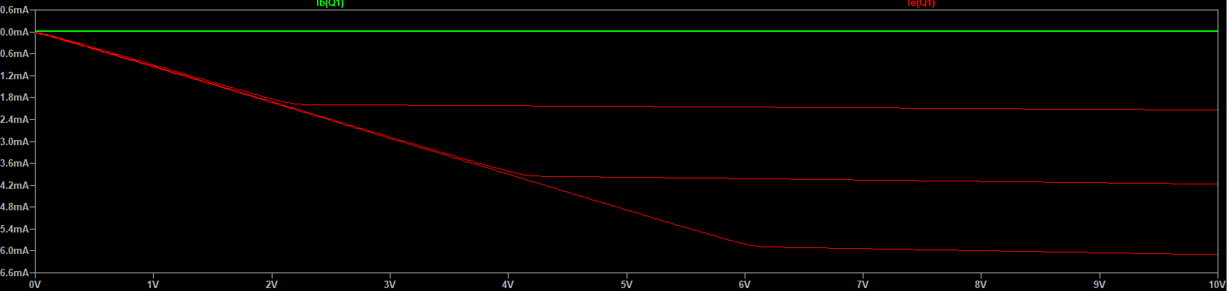

Figure 22 IC=f(UCE) Plot Characteristic

Please note in Figure 21 the step function is barely visible, therefore please find Figure 22 that presents a zoomed in copy of Figure 22, to prove the step function actually existing and working. (However, this is more visible in the red plot of the emitter current, whilst the base current is the one that isn’t very visible).

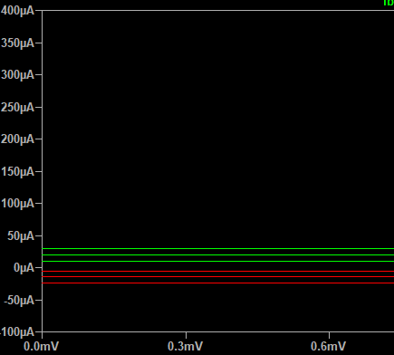

Figure 23 Zoomed in IC=f(UCE) Plot Characteristic.

The next part of the exercise is to show the output characteristic IC=f(UCE) with specific values of the transistor β and current gain. Therefore the bf parameter has been set up with the use of the .step function below please see Figure 23 containing mentioned syntax directive included in the circuit scheme.

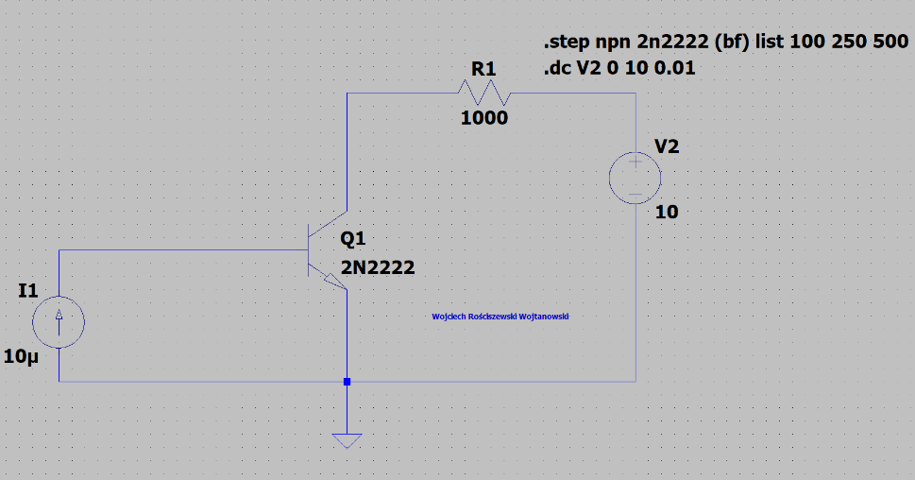

Figure 24 Circuit from Figure 20 with .step SPICE Directive

The simulation has been run, please see the following results below. Please see that the simulation varies in results in comparison to before the bf parameter change seek Figure 21 with reference to the axis. We see that the characteristic changes, the curve is more step

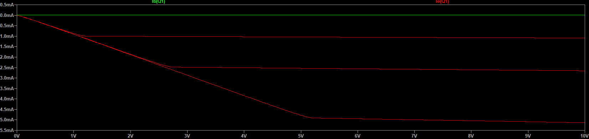

Figure 25 BF parameter change IC=f(UCE) Plot Characteristic.

# Part 6: Homework

## Task 1:

Below please find the first homework task for the forward and backward characteristics for the rectifier diode.

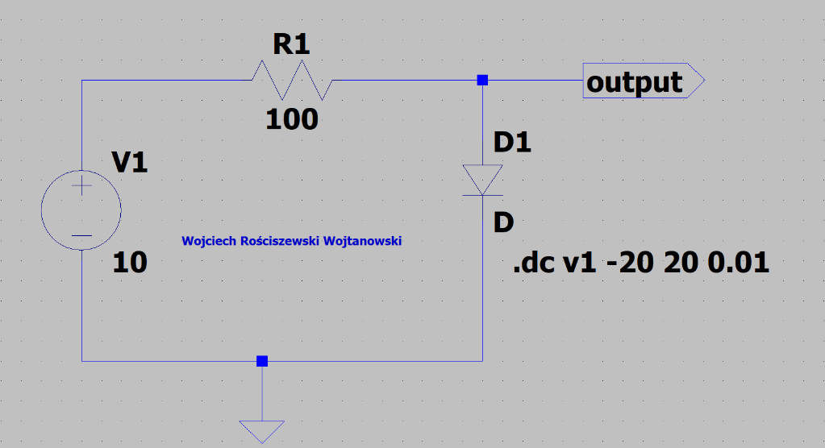

Figure 26 Circuit for Rectifying Diode.

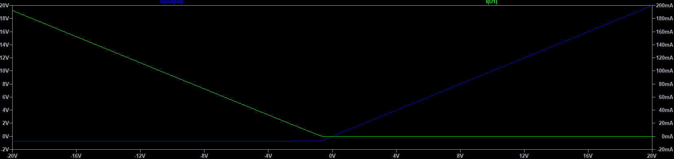

Figure 27 Forward Bias

For the reverse bias I will simply turn the diode around in the circuit. So that the cathode is facing North (towards output).

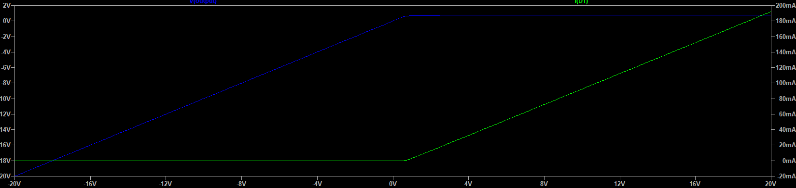

Figure 28 Reverse Bias

## Task 2:

Below please find the second homework task for the forward and backward characteristics for the Schottky diode.

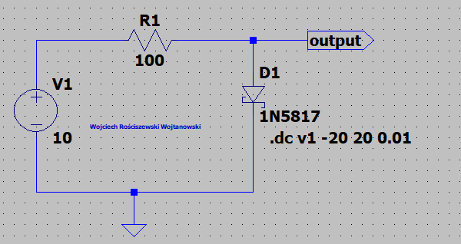

Figure 29 Schottkey Diode Circuit

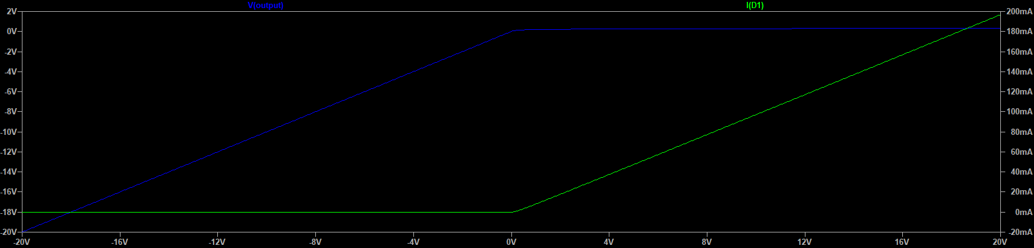

Figure 30 Reverse Characeristic.

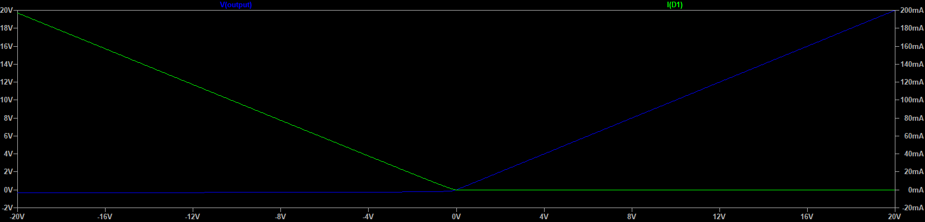

Figure 31 Forward Characteristic.

## Task 3:

Below please find the third homework task for the calculation of the R1 and R2 resistances so that the static operating point of the transistor is IC=5mA and UCE=5V from the circuit presented in Figure 31 found in the below.

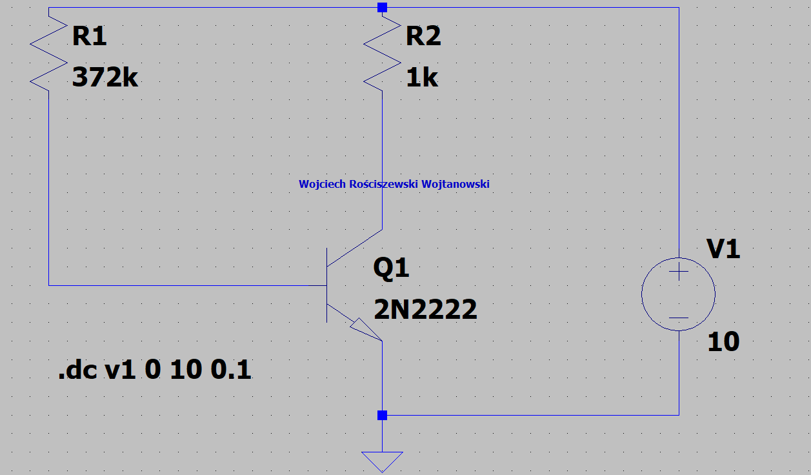

Figure 32 Determination of the Static Operating Point of the Transistor. R1=372k R2=1k.

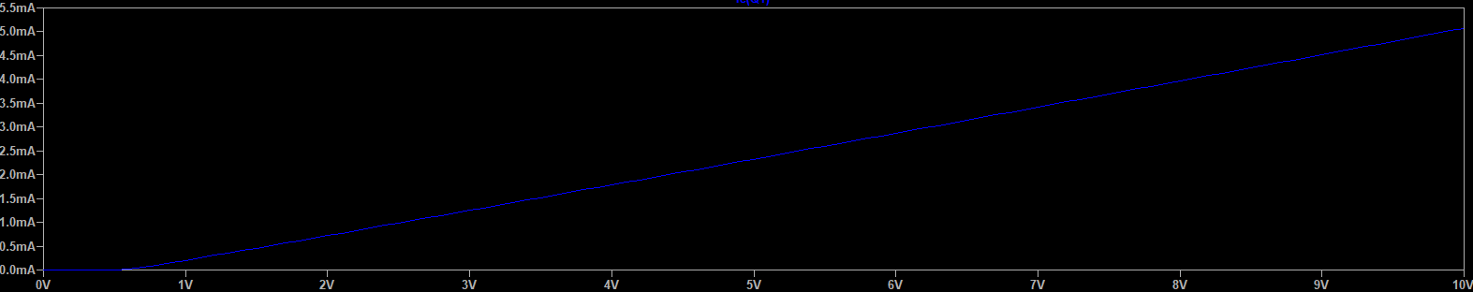

Figure IC

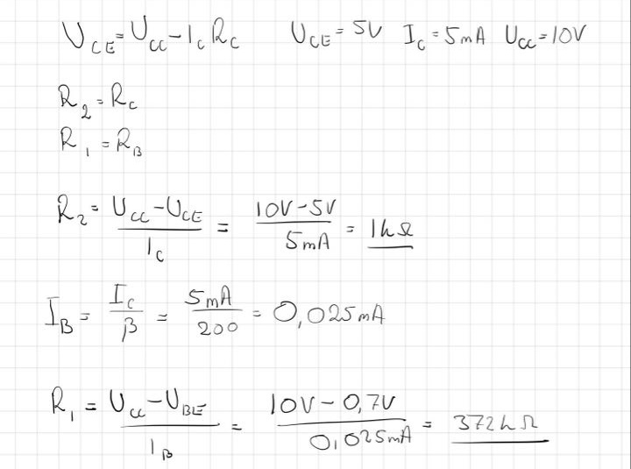

Figure Calculations